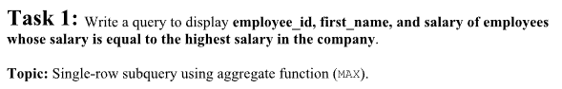

select employee_id, first_name, salary
from employees
where salary = (select max(salary) from employees);

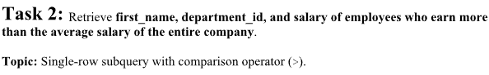
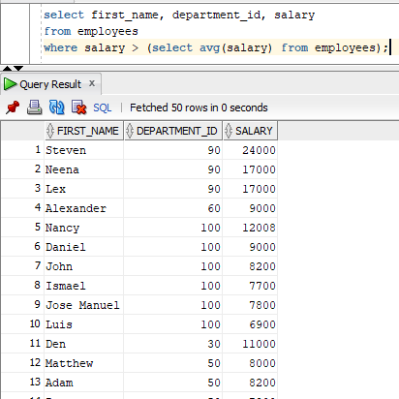
select first_name, department_id, salary
from employees
where salary > (select avg(salary) from employees);


select employee_id, first_name, department_id
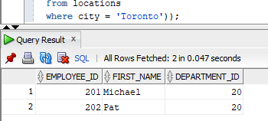
from employees
where department_id in
(select department_id
from departments
where location_id in
(select location_id
from locations
where city = 'Toronto'));
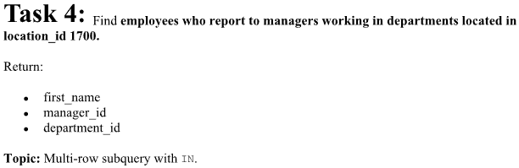
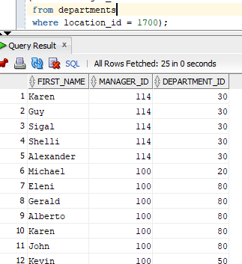
select first_name, manager_id, department_id
from employees
where manager_id in
(select manager_id
from departments
where location_id = 1700);


select first_name, job_id, salary
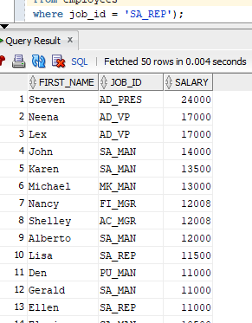
from employees
where salary > any
(select salary
from employees
where job_id = 'SA_REP');



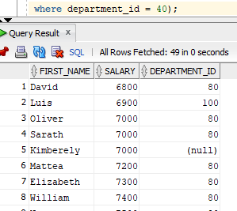
select first_name, salary, department_id
from employees
where salary > all
(select salary
from employees
where department_id = 40);



select employee_id, first_name, salary, department_id
from employees e
where salary >
(select avg(salary)
from employees
where department_id = e.department_id);

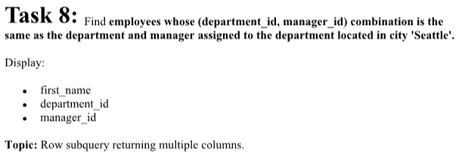
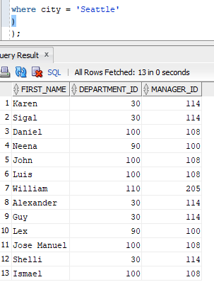
select first_name, department_id, manager_id
from employees
where (department_id, manager_id) in
(
select department_id, manager_id
from departments
where location_id in
(
select location_id
from locations
where city = 'Seattle'
)
);

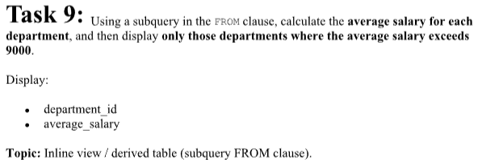
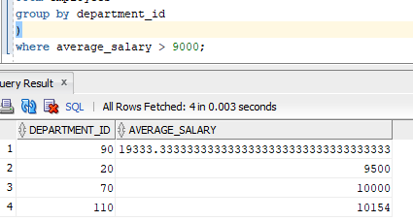
select department_id, average_salary
from
(
select department_id, avg(salary) as average_salary
from employees
group by department_id
)
where average_salary > 9000;

